**Document to Deploy Jenkins in Openshift**

1. Setup the openshift followed by earlier docs, i.e. Ansible setup docs for Openshift. Get the Public login url of Openshift and login into portal using command https://<pulbic_ip_of_openshift_master_instance>:8443
2. Put the login credentials username:system and password: admin

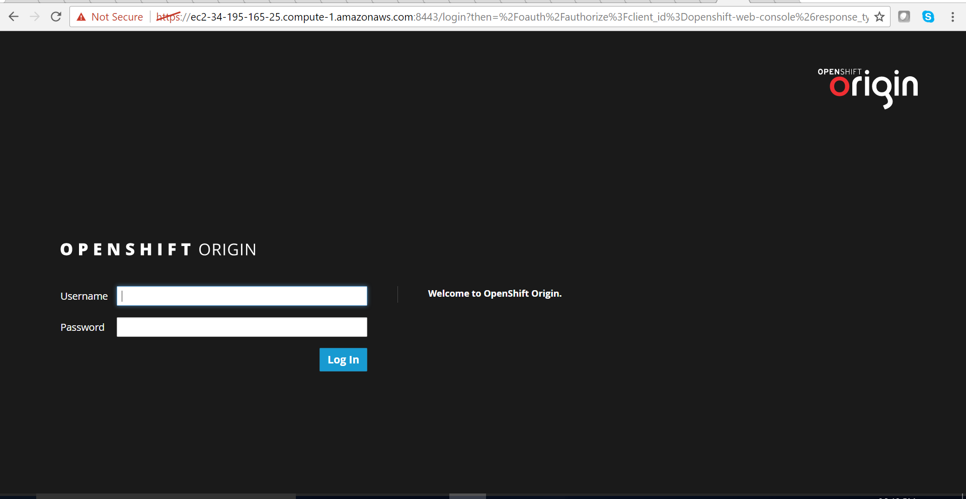

1. Login into portal and click on new_project button and create new project for Jenkins.

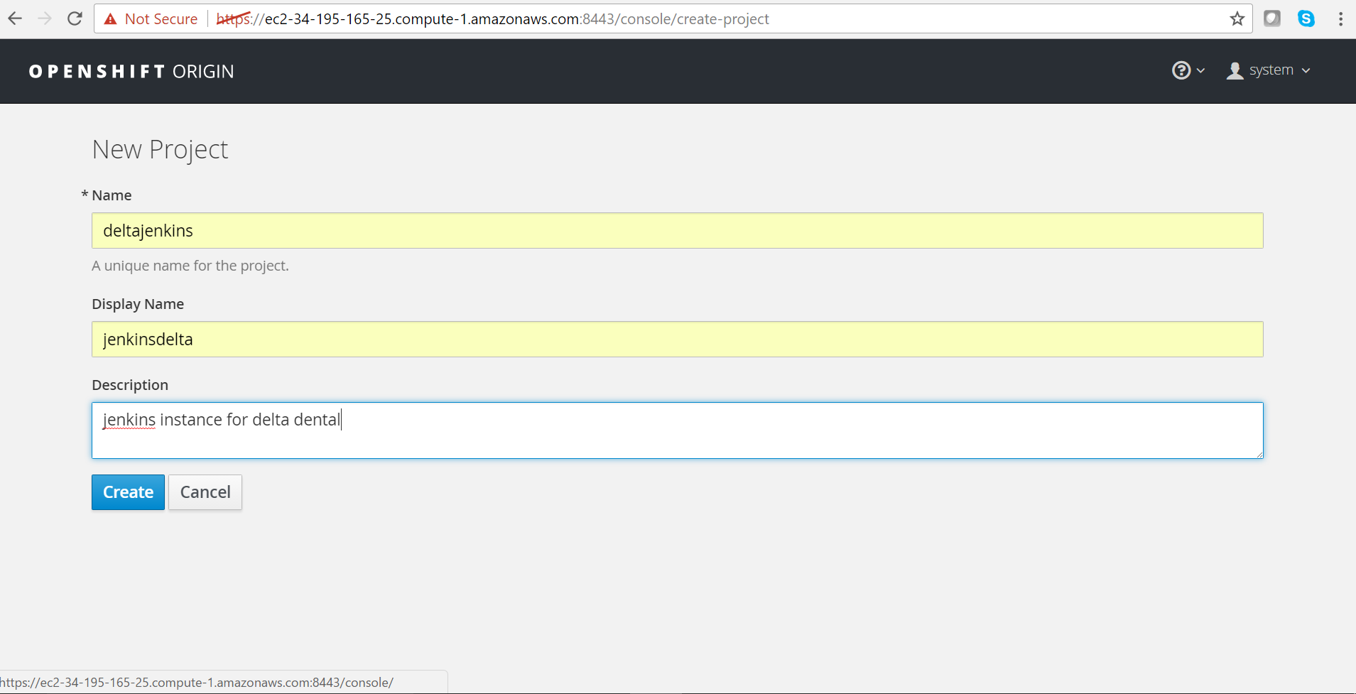

1. Fill the information as mentioned above and click on create.
2. Select the Jenkins image as mentioned in CatLog. 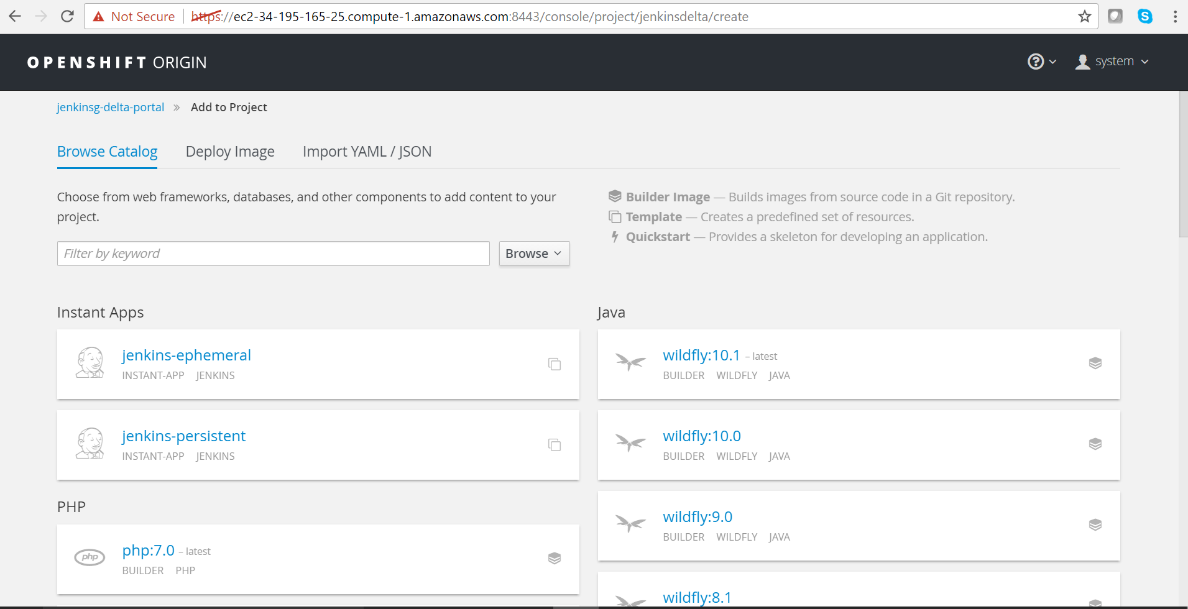
3. Click on Jenkins-ephermal to create new Jenkins project. You will get screen as shown below.

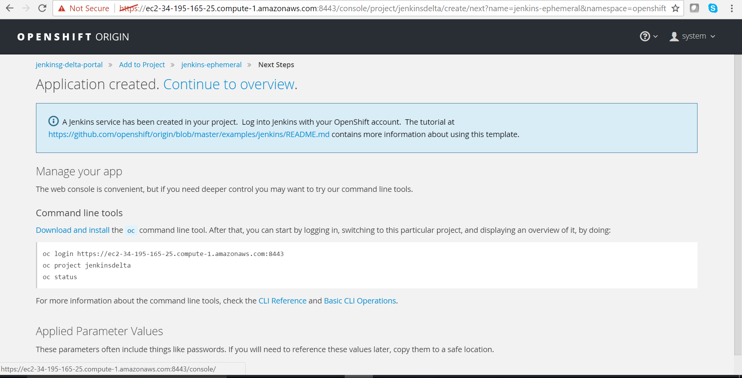

1. Click on continue overview, and then the page will be redirect to the Jenkins creation deployment.

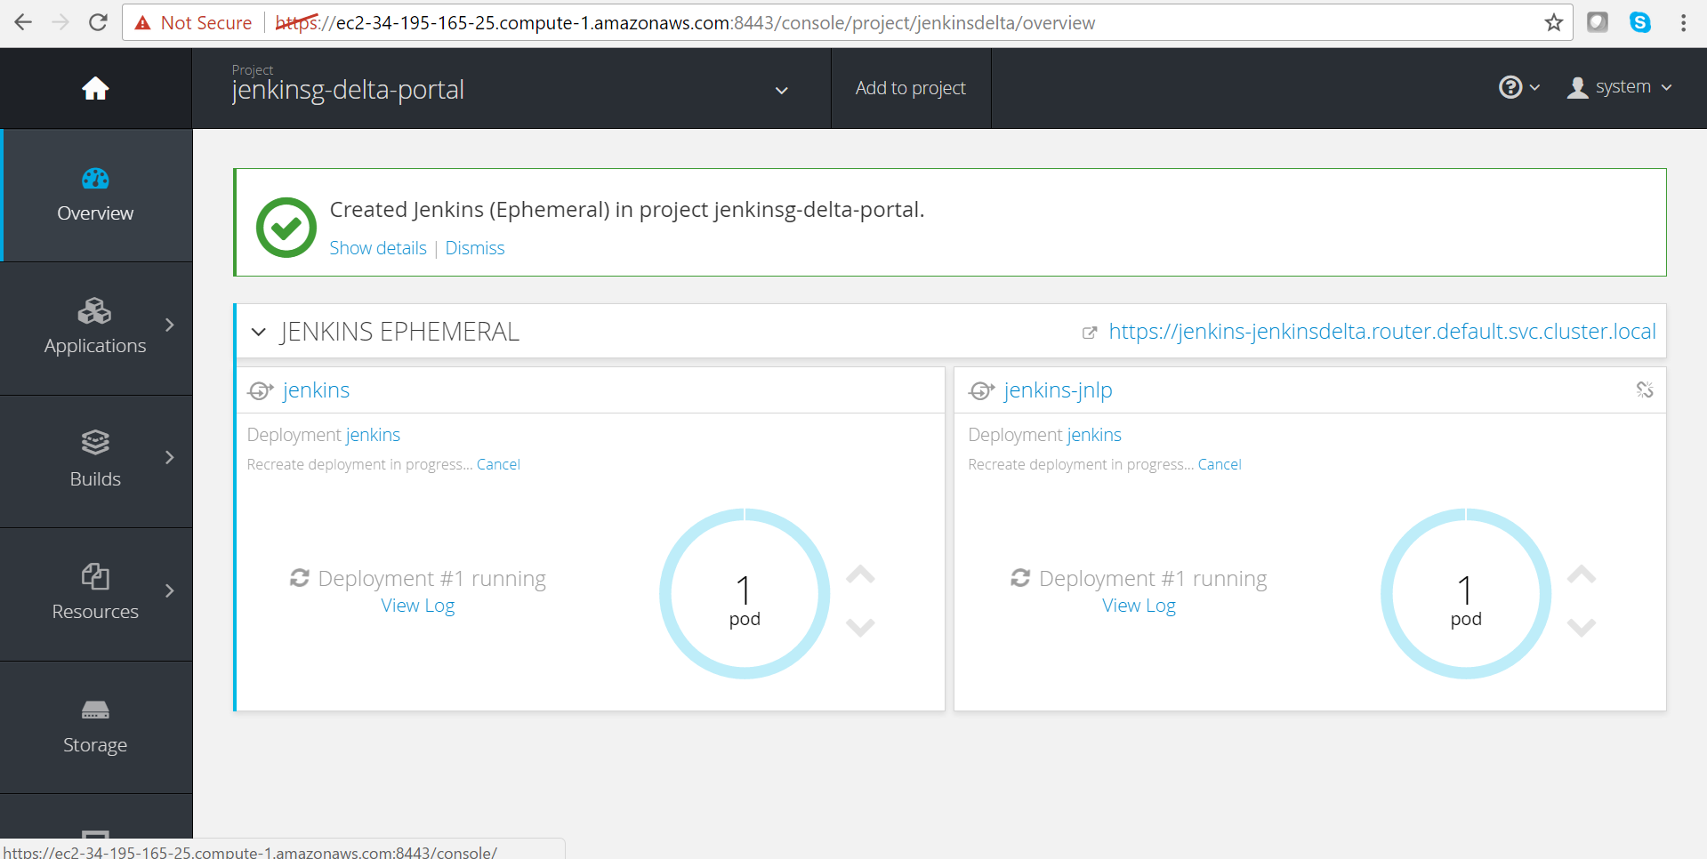

1. Wait for 2 mins to get pods ready for deployment, and you can see dark sky blue colours instances.

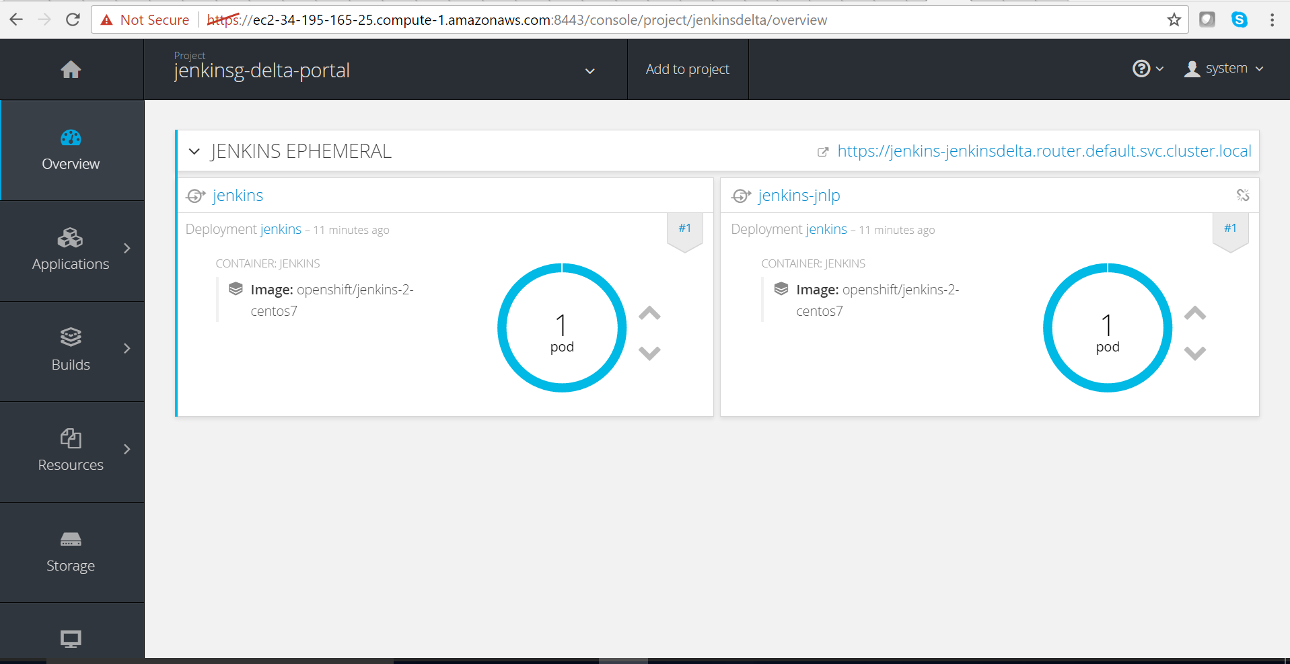

1. Click on running pod1, you will get below console

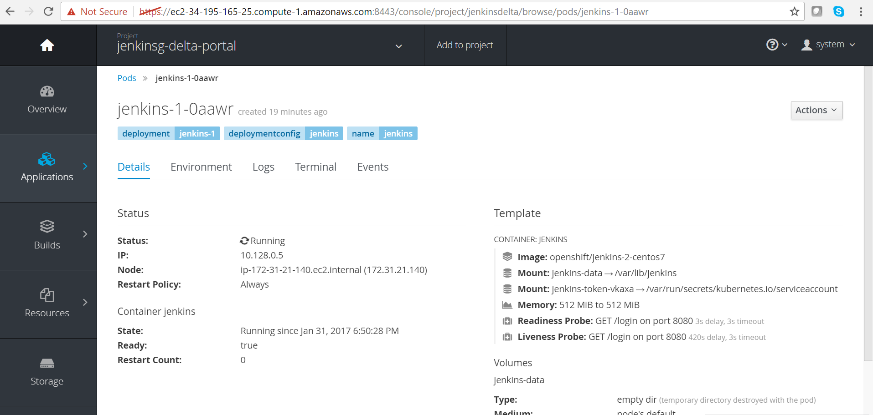

1. Create the tunnel from the private ip i.e node ip you can see in above screen shot, please follow below process to tunnel private ip instance of Jenkins docker, login into putty session as shown below.

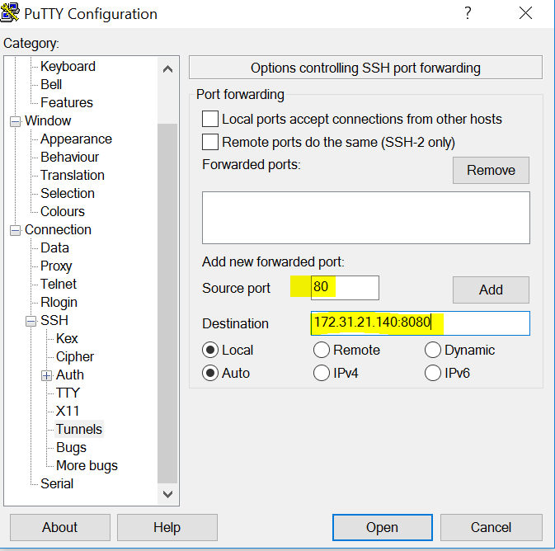

1. Put source port is the localhost post use for access Jenkins url, in this case it port 80. Destination port is the port with private ip address for ec2 instance master openshift cluster, with port number where Jenkins running inside docker instance i.e. 8080. Add above port in the add list.

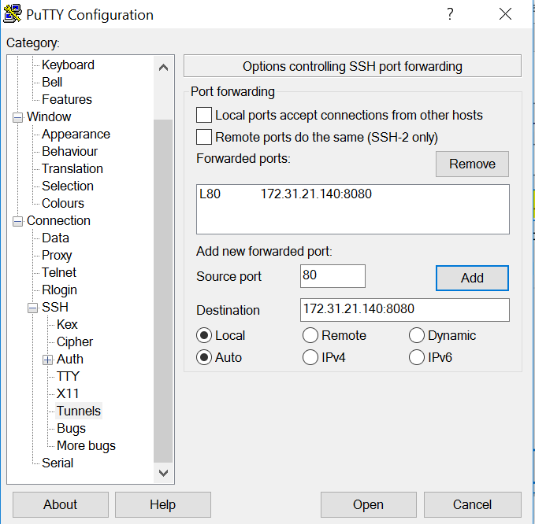

1. Go to seesion tab and put username with public ip any ec2 instance within same subnet of Jenkins docker ec2 instance.

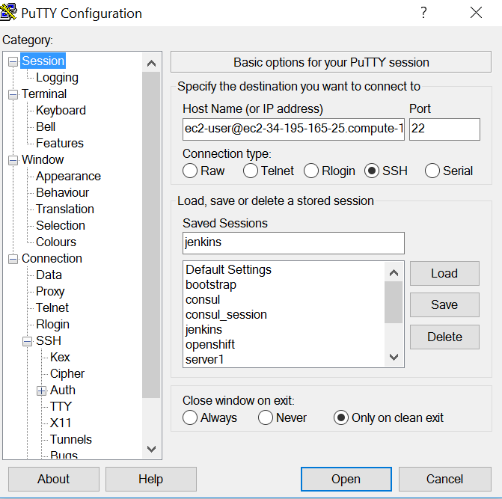

1. Put security key insight Authentication portal and login the box, this box is use as port forwarding between Jenkins docker instance and localhost network.
2. Go to browser and open Jenkins using <http://localhost:80> url.